## Pitch

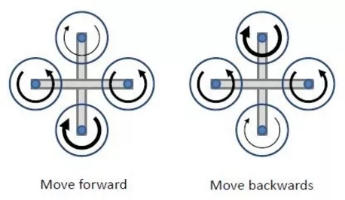

Figure 3.g: Pitch (bold arrow represent higher rotation per minute)

To move forward (upward), RPM of the rotor at the bottom is increased so it generates more lift. Which tilt the system in forward direction as explained previously.

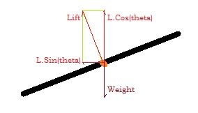

Figure 3.h: Imbalanced momentum

A component of lift [LSin(θ)] is in forward direction which causes the system to accelerate in the forward direction